# **EN.585. 788: Foundations of Computational Biology and Bioinformatics – Project Rough Draft**

**Authors: Yves Greatti, Reem Abu Shamma, Lungzhu Shen**

**Abstract**

Single-cell RNA sequencing (scRNA-seq) has enabled the identification of new cell subtypes and gene expression patterns within tumors. However, the cost and technical complexity of scRNA-seq still makes it impractical for large-scale clinical studies. Therefore, a promising approach is to use computational methods to deconvolve the cell-type composition of bulk RNA sequencing data, which can provide insights into the molecular mechanisms underlying the development and progression of cancer.

In this study, we applied a single-cell RNA deconvolution method to bulk RNA sequencing data from the Cancer Genome Atlas (TCGA) breast cancer (BRCA) dataset to identify cell-type-specific gene expression signatures associated with overall and disease-free survival. We used the Single-Cell Expression Atlas (SCEA) database to generate a reference gene expression matrix for 9 different breast cell types, including luminal and basal epithelial cells, myoepithelial cells, and immune cells. We also used a dataset from an existing publication in the literature (Gray et al.) that identifies cells related to breast cancer at both the transcriptomic and proteomic levels such as mammary epithelial cells (MEC), alveolar (AV), Hormone Sensing (HS), basal (BA), and stromal cells (fibroblasts, vascular/lymphatic cells, and immune cells) [1]. We then applied the Multi-subject Single-cell Deconvolution (MuSiC) algorithm to estimate the relative proportions of these cell types in the bulk RNA sequencing data [2].

We identified cell-type-specific gene expression signatures associated with overall survival in breast cancer (BRCA) patients; expression of genes associated with B or T cells was positively associated with overall survival. These findings suggest that the immune response to BRCA tumors may play an important role in patient survival.

Our study demonstrates the potential of single cell RNA deconvolution methods to identify cell-type-specific gene expression signatures associated with clinical outcomes in large-scale clinical datasets. This approach may lead to the development of more effective diagnostic and therapeutic strategies for BRCA patients.

**Introduction**

Cancer cells produce cytokines and chemokines that attract a diverse population of immune cells, including macrophages, neutrophils, and lymphocytes. The impact of these tumor-infiltrating immune cells has been debated. Some groups have shown that tumor-infiltrating immune cells may physically destroy tumor cells, thereby reducing tumor burden and improving clinical prognosis [8]. However, persistent activation of the immune system and failure of the inflammatory response to resolve may lead to chronic inflammation, which promotes tumor growth [7]. This inflammation promotes genomic instability, epigenetic modifications, and upregulation of cancer anti-apoptotic pathways, highlighting potential mechanisms of inflammation in promoting tumor growth and possibly metastasis [10].

Recent studies have shown that accounting for the heterogeneity of immune cell infiltration can result in more sensitive survival analyses and more accurate tumor subtype predictions [3,4]. Ongoing research is focused on the role of infiltrating lymphocytes and other immune cells in the tumor microenvironment (TME). Myeloid cells such as macrophages, monocytes, dendritic cells, neutrophils, basophils, and eosinophils are frequently found in the tissue of various tumors. In malignant tumors, levels of infiltrating immune cells are associated with tumor growth and cancer progression [5, 6].

Bulk RNA sequencing measures the average gene expression across all cells within a sample, and therefore cannot distinguish between different cell types or states. On the other hand, scRNA-seq enables researchers to identify and profile the transcriptome of individual cells, allowing for the characterization of cell types and their heterogeneity within a sample. By comparing bulk RNA expression data to scRNA-seq data from the same or similar tissues, deconvolution algorithms estimate the proportions of different cell types present in the bulk sample.

Breast cancer (BRCA) is one of the most common cancers among women worldwide. Despite advances in treatment, the prognosis for patients with BRCA remains highly variable. Recent studies have demonstrated that the heterogeneity of tumor cells and the TME can significantly impact patient outcomes, with greater heterogeneity corresponding to less immune cell infiltration, less activation of the immune response, and worse survival in breast cancer [9]. Identifying the cell-type-specific molecular mechanisms is needed to improve our understanding of the development and progression of BRCA tumors, and ultimately in enhancing diagnostic and therapeutic strategies.

The molecular subtypes of breast cancer depend on the genes the cancer cells express. The main molecular subtypes of invasive breast cancer are as follows [11]:

* Luminal A breast cancer: estrogen receptor (ER)-positive and progesterone receptor-positive, human epidermal growth factor receptor 2 (HER2) negative and has low levels of the protein Ki-67.
* Luminal B breast cancer: estrogen receptor-positive and HER2-negative, and either have high levels of Ki-67 or is progesterone receptor-negative
* HER2-enriched breast cancer: estrogen receptor-negative, progesterone receptor-negative, and HER2-positive
* Triple-negative breast cancer (TNBC) or basal-like breast cancer: lacks estrogen and progesterone receptors, lacks HER2 expression, is more prevalent in individuals with a BRCA1 mutation, and is the most aggressive subtype

**Methods**

The population data for this study was sourced from the Cancer Genome Atlas (TCGA) project, a collaborative effort between the National Cancer Institute (NCI) and the National Human Genome Research Institute (NHGRI) to systematically analyze and catalog genomic and molecular data from various types of cancer. The TCGA data on BRCA includes information on DNA mutations, gene expression, epigenetic changes such as DNA methylation, and clinical data related to cancer survival and demographics. The TCGA-BRCA project consists of data from 1,111 cancer patients and 113 disease-free control patients. RNA sequence data selected for this study was of the "Primary" and "Solid Tissue Normal" categories. Since MuSiC performs its own normalization, *unstranded* data was only considered and *TPM normalized* data were disregarded. The median age of the cohort was 58 years, and most patients were white (75.6%). The two most common subtypes of BRCA were BRCA_LumA (50.9%) and BRCA_LumB (20.1%), with most patients at stage IIA (32.9%), stage IIB (23.6%), and stage IIIA (14.4%) (Table 1). Data was collected using TCGAbiolinks and TCGAWorkflow packages in R. To ensure consistency across the data, the ENSEMBL Id genes present in the TCGA dataset were converted into gene symbols using the genomic centric EnsDb.Hsapiens.v79 package. Any genes that were unresolved or duplicated were subsequently removed from the expression count matrix, to prevent any discrepancies or confounding factors in the downstream analysis.

|  |  |  |
| --- | --- | --- |
| Normal Cohort Statistics |  |  |
| Age |  |  |
|  | **Count** | 113 |
|  | **Mean** | 57.33 |
|  | **Std** | 14.58 |
|  | **Min.** | 30 |
|  | **25%** | 45 |
|  | **50%** | 56 |
|  | **75%** | 66 |
|  | **Max** | 90 |
|  |  |  |
| Race |  |  |
|  | **Asian** | 1 (0.9%) |
|  | **Black or African American** | 6 (5%) |
|  | **White** | 105 (92.9%) |
|  | **Not Reported** | 1 (0.9%) |

|  |  |  |
| --- | --- | --- |
| Tumor Cohort Statistics |  |  |
| Age |  |  |
|  | **Count** | 1,111 |
|  | **Mean** | 58.42 |
|  | **Std** | 13.21 |
|  | **Min.** | 26 |
|  | **25%** | 49 |
|  | **50%** | 58 |
|  | **75%** | 67 |
|  | **Max** | 90 |
|  |  |  |
| Race |  |  |
|  | **American Indian or** **Alaska Native** | 1 (0.01%) |
|  | **Asian** | 60 (0.6%) |
|  | **Black or African American** | 182 (18.3%) |
|  | **White** | 751 (75.6%) |

_____________________________________________________________________________

**Table 1:** Characteristics of tumor (top) and normal (bottom) cohorts obtained from TCGA for further analysis

For scRNA-seq data, two studies and their datasets were considered:

* Wu et al. (**GSE177078**) provided a more detailed understanding of the cellular and molecular heterogeneity within breast tumors [11]. The researchers performed scRNA-Seq (Chromium, 10X Genomics) on 26 primary tumors from three major subtypes of breast cancer (11 ER+, 5 HER2+, and 10 TNBC) and identified 9 major cell types, 29 minor cell types and 49 cell subtypes (Table 2). The study also found that macrophages with high expression of fatty acid metabolic genes FABP5 (LAM1), as well as macrophages that clustered around high levels of CXC chemokines 10 (CXCL10-hi) are key sources of immunosuppressive molecules within the human breast TME. Spatial analysis revealed the proximity of these macrophages to lymphocytes expressing programmed cell death 1 protein (PD-1+ lymphocytes). They also identified that the LAM1 gene signature is strongly correlated with poor patient survival in large patient datasets, emphasizing the crucial role of these cells in the development and progression of breast cancer.
* The second study and its corresponding dataset, Pal et al. (**GSE161529**), presents an extensive single-cell transcriptome map of over 430,000 cells (Table 3), from 52 patients [12]. They obtained the samples under various conditions including differing hormonal stages, preneoplastic BRCA1+/- tissue, different cancer subtypes (4 TNBCs, 4 BRCA1 TNBCs, 6 HER+ tumors), as well as matching tumor and involved axillary lymph node pairs. The data was downloaded using the GEOquery package.

|  |  |
| --- | --- |
| Major Type | Minor Type |
| B-Cells | B Cells Memory |
|  | B cells Naive |
| CAFs | CAFs MSC iCAF-like |
|  | CAFs myCAF-like |
| Cancer Epithelial | Cancer Basal SC |
|  | Cancer Cycling |
|  | Cancer Her2 SC |
|  | Cancer LumA SC |
|  | Cancer LumB SC |
| Endothelial | ACKR1 |
|  | CXCL12 |
|  | Endothelial Lymphatic LYVE1 |
|  | RGS5 |
| Normal Epithelial | Luminal Progenitors |
|  | Mature Luminal |
|  | Myoepithelial |
| Myeloid | Cycling Myeloid |
|  | DCs |
|  | Macrophage |
|  | Monocyte |
| PVL | Cycling PVL |
|  | PVL Differentiated |
|  | PVL Immature |
| T-cells | Cycling T-cells |
|  | NK cells |
|  | NKT cells |
|  | CD4+ |
|  | CD8+ |

**Table 2: Identification** of major and

minor cell types from Wu et al. [11].

|  |  |
| --- | --- |
| Major Type | Minor Type |
| AV | AP |
|  | BAa |
|  | BAb |
|  | BAx |
|  | BL |
|  | Has |
|  | Hsb |
|  | HSx |
| BA | AP |
|  | BAa, BAb, BAx, BL |
|  | HSb, HSx |
|  | HSx |
| Fibroblast | F1, f2, F3, Fx |
|  | I1 Myeloid cell |
|  | VL3 Pericyte |
| HS | AP |
|  | BAb, BAx, BL |
|  | Has, HSb, HSx |
| Immune | F3, Fx Fibroblast |
|  | I1 Myeloid cell |
|  | I2 NK cell |
|  | I3 T cell |
|  | I4 B cell |
|  | I5 Plasma cell |
|  | VL2 Vascular endothelial |
|  | VL3 Pericyte |
| Vascular and lymphatic | F3, Fx Fibroblast |
|  | VL1 Lymphatic endothelial |
|  | VL2 Vascular endothelial |
|  | VL3 Pericyte |

Table 3: Identification of major and

minor cell types from Pan et al. [11].

We then investigated the potential correlation between cellular fractions and clinical outcomes in the TCGA BRCA cohort. To this end, we conducted survival analyses using TCGA clinical data obtained through the cBioPortal and the cBioPortalData R package. Specifically, we utilized a median-point strategy to divide patients into low and high cell type proportions. We then performed Kaplan-Meier survival analyses with a log-rank test using a Cox's proportional-hazard model from the Python package, *lifelines*. We then computed the hazard ratio with a 95% confidence interval and corresponding p-values, and generated Kaplan-Meier curves using the Kaplan Meier Estimator function in the Python package, *scikit-survival*. Overall, these analyses allowed us to assess any potential associations between cellular alterations and clinical outcomes, including overall survival (OS) and disease-free survival (DFS) of patients in the TCGA BRCA cohort.

To identify oncogenes from the estimated cell proportions we used the PROGENy R package, and the Python package, *decoupler.* PROGENy, performs gene set enrichment analysis (GSEA) and pathway analysis of gene expression data. The decoupler Python package utilizes statistical methods such as Weighed Sum (WMEAN) or Univariate Linear Model (ULM) and a prior knowledge on gene regulatory networks to predict the activity of transcription factors and pathways within a sample population.

**Results**

**Deconvolution of Immune Cells From RNA-Seq Data**

Using MUSiC for single-cell deconvolution, we were able to estimate the proportions of different immune cell subpopulations within each patient's tumor.

**GSE161529**

To test our deconvolution technique, we first applied MUSiC to the 113 disease-free control normal patients within the GSE161529 cohort and compared to results to normal TCGA patients. The disease-free control patients in our TCGA BRCA cohort had high proportions of HS, AV, and vascular and lymphatic cells (Fig 1A). This was consistent with those found in normal TCGA patients (Fig 1B) , which provided validity to our method.

**A**

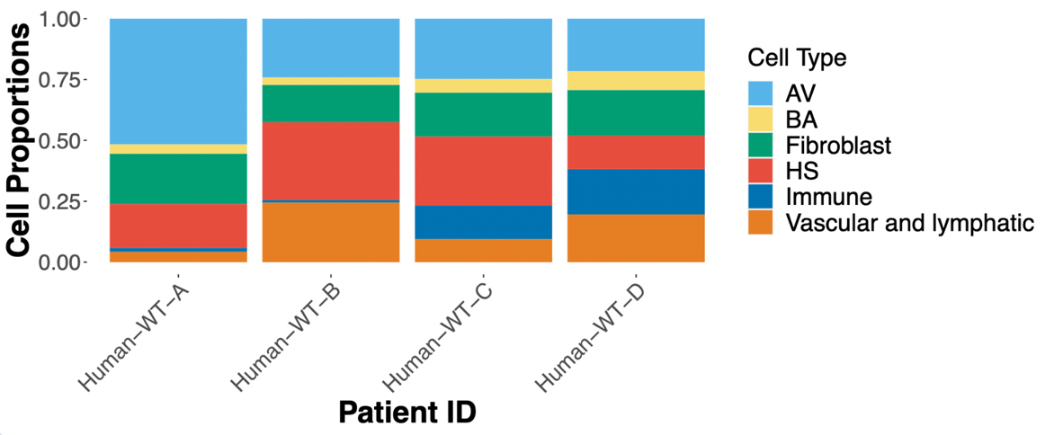

**B**

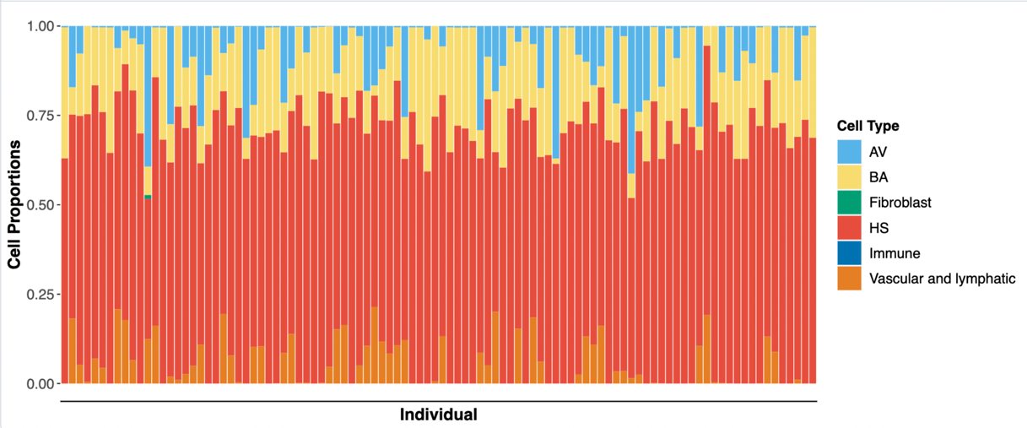

**__________**

**Figure 1:** Cell type proportions from single-cell deconvolution using MUSiC of normal patients. Fig **1A.** Cell type proportions within the 113 disease-free control patients (top). **Fig 1B.** Cell types of normal patients in our TCGA BRCA cohort (bottom).

In GSE17078 patients, a significant presence of immune cells, such as macrophages, monocytes, and T cells (CD4+ and CD8+), was observed, with similar proportions found in TCGA breast cancer patients (Fig. 2) -. However, upon excluding macrophages and non-immune cells, we observed a substantial presence of NK and NKT cells, as well as B cells (memory B cells) to a lesser extent (Fig. 3). These findings highlight the complex and diverse nature of the immune cell composition within breast cancer tumors.

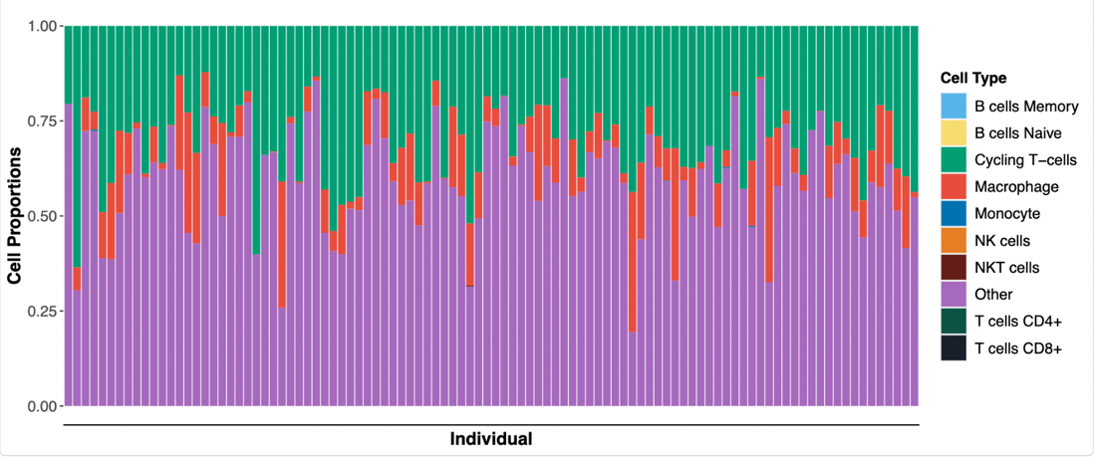





**Figure 2:** Cell type proportions from single-cell deconvolution using MUSiC of tumor patients. Fig **2A.** Cell type proportions in TCGA BRA cohort (top). **Fig 1B.** Cell type proportions in TCGA BRA cohort for immune cells(top (bottom).

Regarding cell subtypes, VL2 vascular endothelial cells and immune I3 T cells were predominant in both TCGA cancer patients and GSE161529 (Fig. 3A, Fig 3C), although their median levels were lower compared to other cell subtypes such as Has, HSx, and BL cell subtypes (Fig 3B).

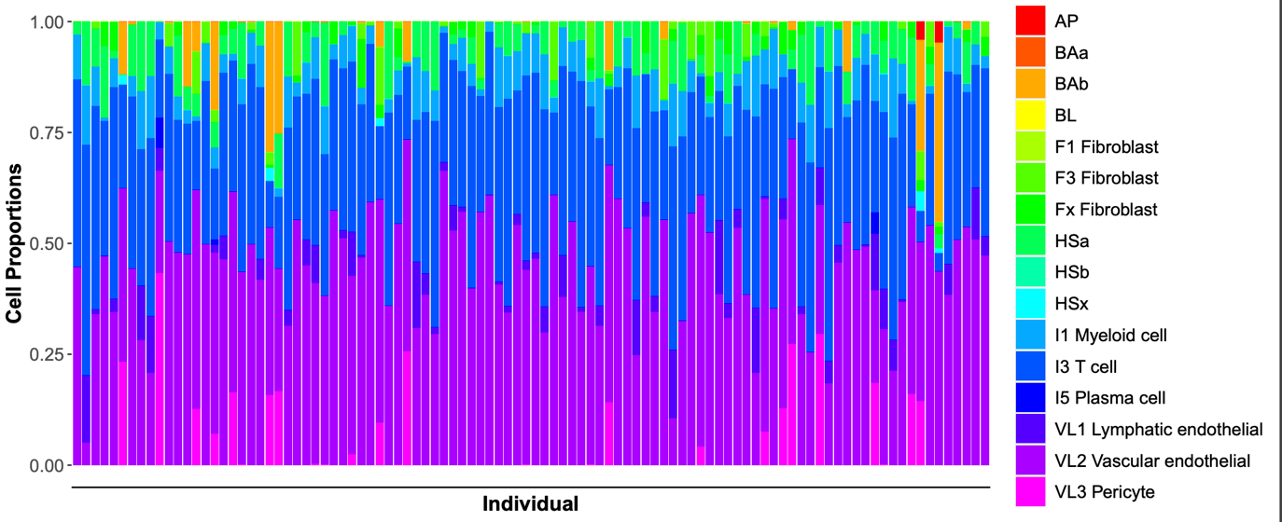

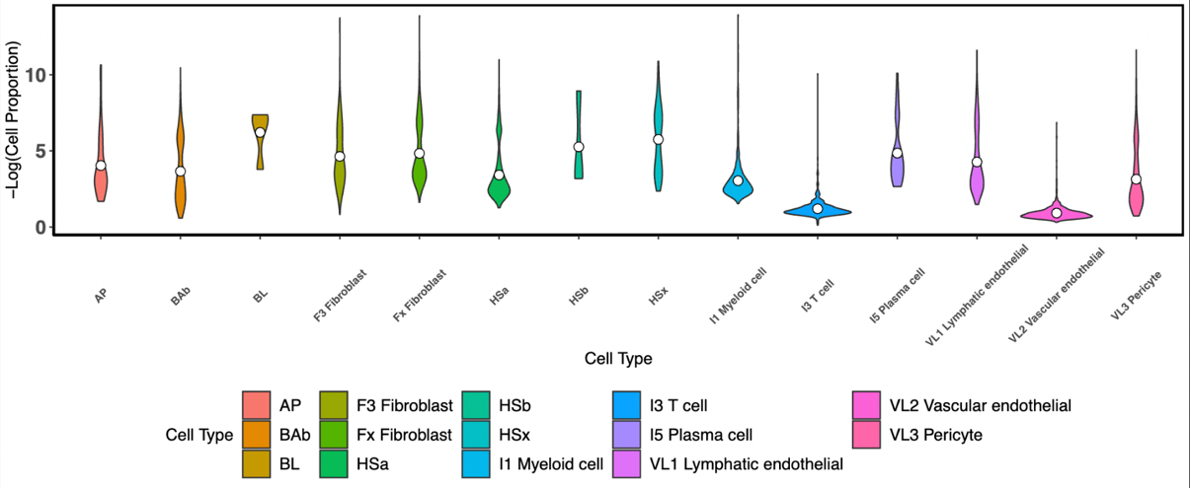

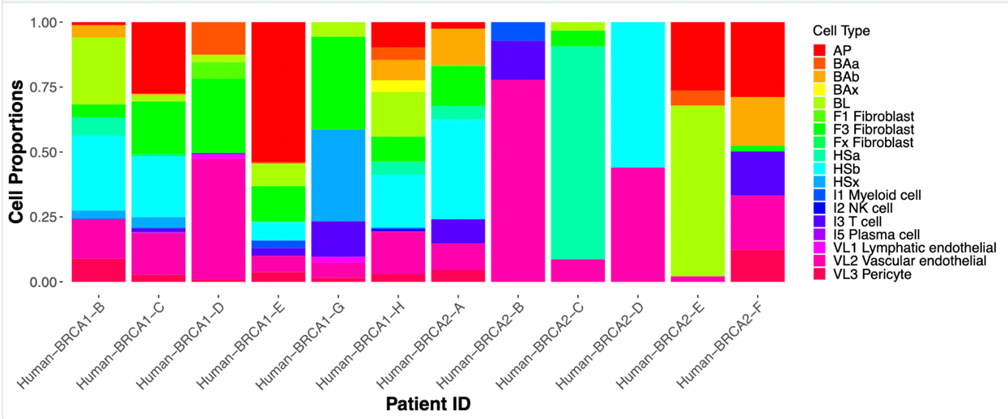

**_____________________________________________________________________________**

**Figure 3:** Cell subtype proportions from single-cell deconvolution using MUSiC of BRCA patients. **Fig 3A-B.** TCGA BRCA cohort cell subtypes represented as stacked bar chart (top) and violin plot (underneath). **Fig 3C.** Cell subtypes ofBRCA tumor patients outside of our TCGA BRCA cohort (bottom).

These results suggest that while some immune cell subtypes are more prominent in breast cancer tumors, there is still significant heterogeneity in the immune cell composition across tumors.

**Cell Fractions Clinical Outcome Correlation**

Our analysis of the GSE177078 cohort suggests that tumor patients with high levels of memory B cells had significantly greater overall survival (OS) and disease-free survival (DFS) when compared to patients with low levels of memory B cells. This difference was not observed for differences in amount of naïve B cells (Figure 6). Levels of CD8+ T cells (Figure 7) and NKT cells (Figure 8) also correlated with improved DFS outcomes, when compared to patients with lower proportions of the same cell types.

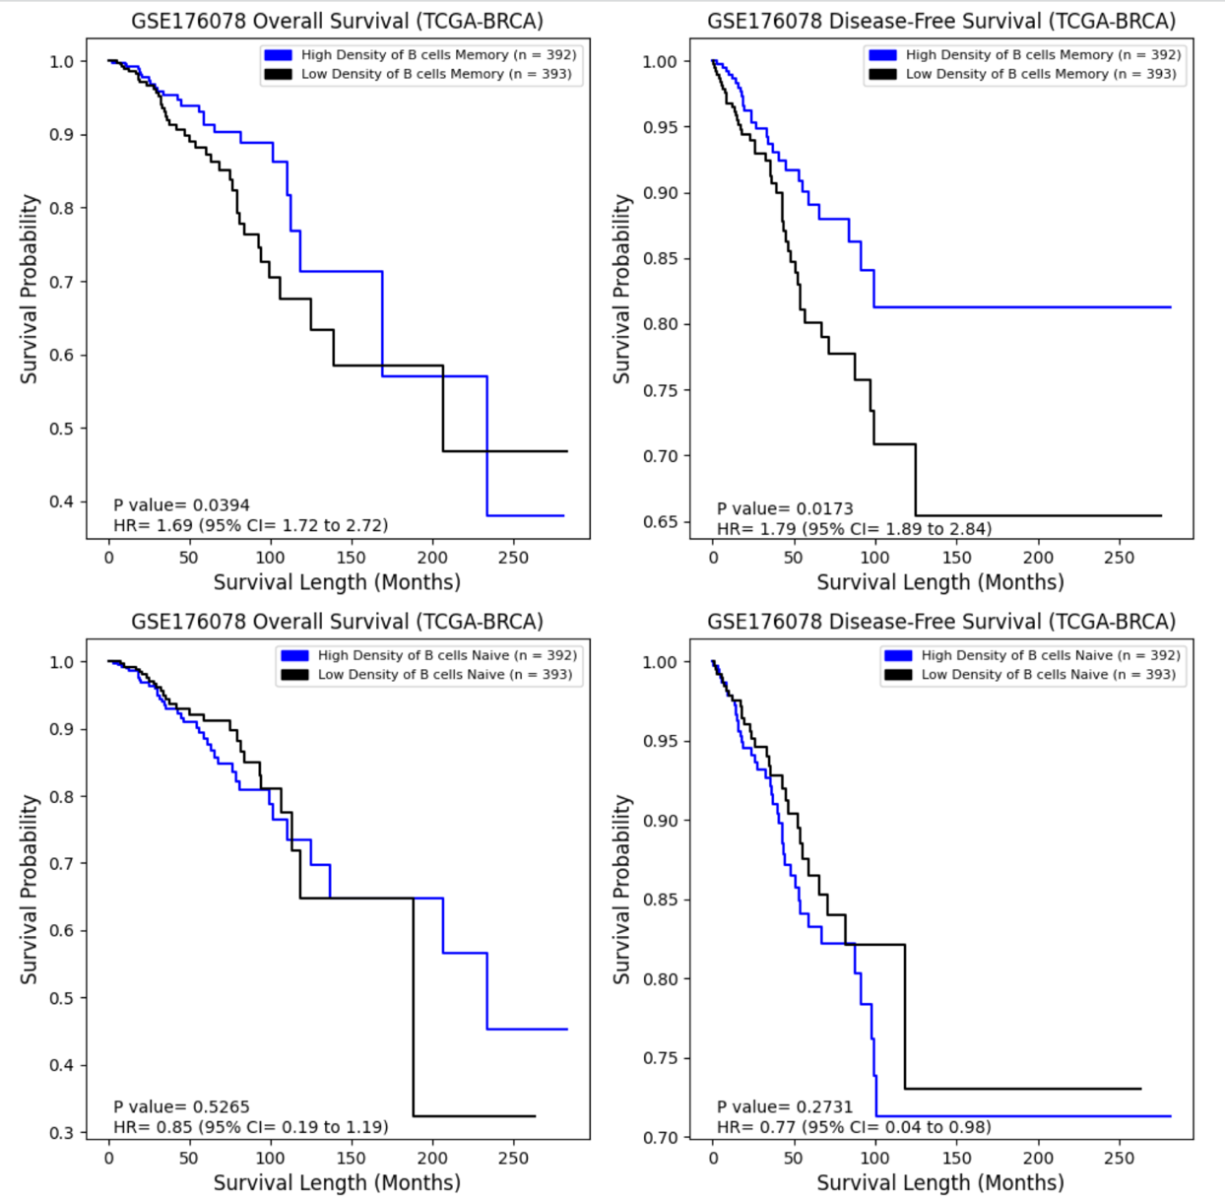

**___________________________________________________________________________**

## **Figure 6:** Difference in overall survival (left panels) and disease-free survival (right panels) across tumor patients in the GSE176078 tumor cohort showing different levels of memory B cells (top) and naïve B cells (bottom).

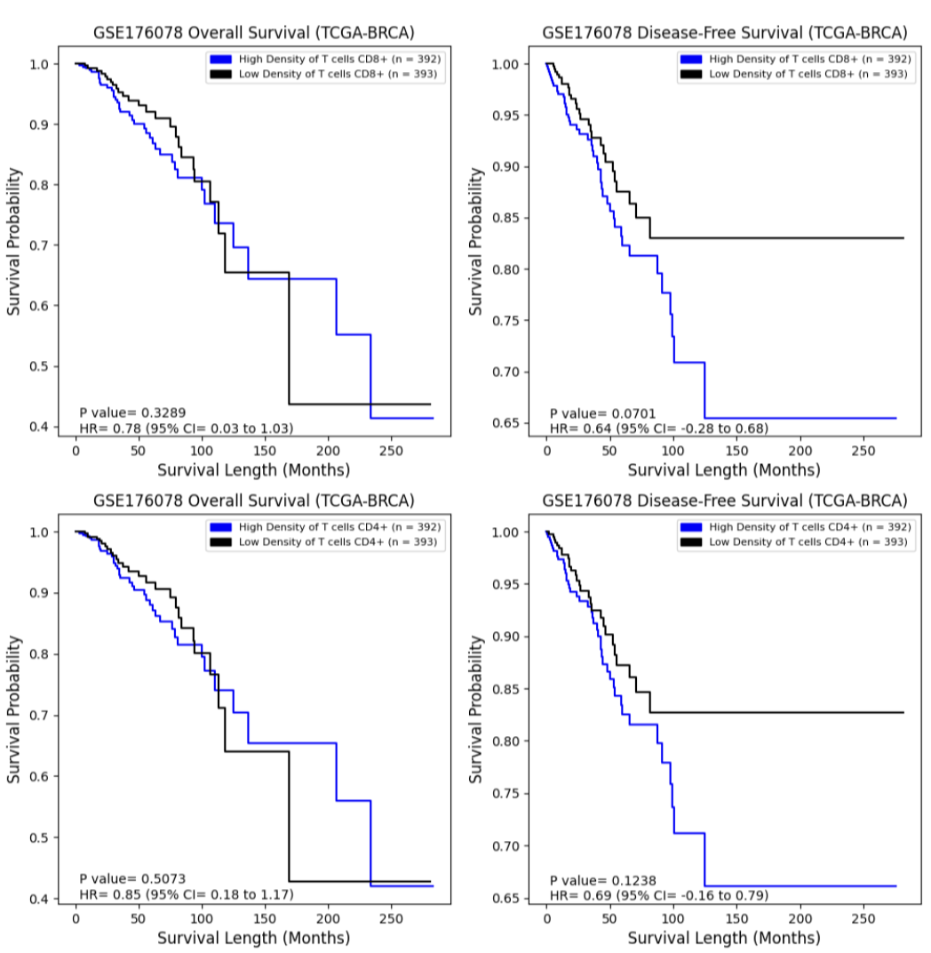

**_____________________________________________________________________________**

**Figure 7:** Difference in overall survival (left panels) and disease-free survival (right panels) across tumor patients in the GSE176078 tumor cohort showing different levels of CD8+ T cells (top) and CD4+ T cells (bottom).

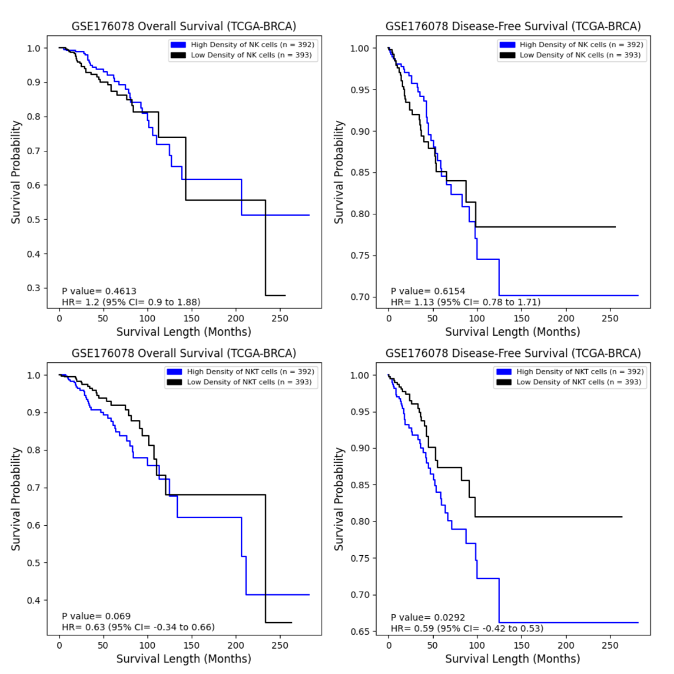**_____________________________________________________________________________**

**Figure 8:** Difference in overall survival (left panels) and disease-free survival (right panels) across tumor patients in the GSE176078 tumor cohort showing different levels of NK cells (top) and NKT cells (bottom).

Interestingly, we did not observe the same trends for the immune cells when using the GSE161529 dataset and corresponding single-cell bulk-RNA deconvolution. Additionally, we found that vascular and lymphatic cells, as well as alveolar cells, did not significantly impact survival outcomes. These results provide insight into the potential prognostic value of specific immune cell subpopulations in BRCA patients and underscore the importance of considering heterogeneity in immune cell composition when assessing clinical outcomes.

**Pathway Analysis**

Within the context of the 14 cancer pathways investigated in our study, immune cells including B, T, and NK cells exhibited a trend of higher activity in pathways that regulate immune responses, such as TGFb, but lower activity in pathways that induce apoptosis, such as Trail. It is noteworthy that these same cell types also demonstrated involvement in the MAPK pathway, which is known to promote cell growth and proliferation. Each gene in PROGENy pathway has a weight corresponding to its up-regulation expression within a given pathway. Sorting these genes by weights we found that ID1, ID3, COM, PMEPA1, SMAD7 in the TGFb pathway and DUSP6, SPRY4, SPRY2, FOSL1, MMP1 in the MAPK pathway are prognostic markers in different cancers. Similar correlations were found with Vascular and lymphatic, BA, HS, Fibroblast and AV cells.

These observations highlight the multifaceted role of immune cells in cancer development and underscore the importance of considering the functional activity of these cells in the context of cancer pathways.

**Discussion:**

* Immunotherapies?

**References:**

1. Gray, G. K., Li, C. M., Rosenbluth, J. M., Selfors, L. M., Girnius, N., Lin, J. R., Schackmann, R. C. J., Goh, W. L., Moore, K., Shapiro, H. K., Mei, S., D'Andrea, K., Nathanson, K. L., Sorger, P. K., Santagata, S., Regev, A., Garber, J. E., Dillon, D. A., & Brugge, J. S. (2022). A human breast atlas integrating single-cell proteomics and transcriptomics. *Developmental cell*, *57*(11), 1400–1420.e7. <https://doi.org/10.1016/j.devcel.2022.05.003>
2. Fan, J., Lyu, Y., Zhang, Q., Wang, X., Li, M., & Xiao, R. (2022). MuSiC2: cell-type deconvolution for multi-condition bulk RNA-seq data. *Briefings in bioinformatics*, *23*(6), bbac430. <https://doi.org/10.1093/bib/bbac430>
3. Huang, Ruichao, et al. “Combining Bulk RNA-Sequencing and Single-Cell RNA-Sequencing Data to Reveal the Immune Microenvironment and Metabolic Pattern of Osteosarcoma.” *Frontiers in Genetics*, vol. 13, Oct. 2022, p. 976990. *DOI.org (Crossref)*, <https://doi.org/10.3389/fgene.2022.976990>.
4. Lai, Wenwen, et al. “Integrated Analysis of Single‐cell RNA‐seq Dataset and Bulk RNA‐seq Dataset Constructs a Prognostic Model for Predicting Survival in Human Glioblastoma.” *Brain and Behavior*, vol. 12, no. 5, Apr. 2022, p. e2575. *PubMed Central*, <https://doi.org/10.1002/brb3.2575>.
5. Manoharan, Malini, et al. “A Computational Approach Identifies Immunogenic Features of Prognosis in Human Cancers.” *Frontiers in Immunology*, vol. 9, Dec. 2018, p. 3017. *PubMed Central*, <https://doi.org/10.3389/fimmu.2018.03017>.
6. Qi, Zongtai, et al. “Single-Cell Deconvolution of Head and Neck Squamous Cell Carcinoma.” *Cancers*, vol. 13, no. 6, Mar. 2021, p. 1230. *DOI.org (Crossref)*, <https://doi.org/10.3390/cancers13061230>.
7. Gonzalez, H., Hagerling, C., & Werb, Z. (2018). Roles of the immune system in cancer: from tumor initiation to metastatic progression. *Genes & development*, *32*(19-20), 1267–1284. <https://doi.org/10.1101/gad.314617.118>
8. Man, Y. G., Stojadinovic, A., Mason, J., Avital, I., Bilchik, A., Bruecher, B., Protic, M., Nissan, A., Izadjoo, M., Zhang, X., & Jewett, A. (2013). Tumor-infiltrating immune cells promoting tumor invasion and metastasis: existing theories. *Journal of Cancer*, *4*(1), 84–95. <https://doi.org/10.7150/jca.5482>
9. McDonald, K. A., Kawaguchi, T., Qi, Q., Peng, X., Asaoka, M., Young, J., Opyrchal, M., Yan, L., Patnaik, S., Otsuji, E., & Takabe, K. (2019). Tumor Heterogeneity Correlates with Less Immune Response and Worse Survival in Breast Cancer Patients. *Annals of surgical oncology*, *26*(7), 2191–2199. <https://doi.org/10.1245/s10434-019-07338-3>
10. Gonzalez, H., Hagerling, C., & Werb, Z. (2018). Roles of the immune system in cancer: from tumor initiation to metastatic progression. *Genes & development*, *32*(19-20), 1267–1284. <https://doi.org/10.1101/gad.314617.118>
11. Orrantia-Borunda E, Anchondo-Nuñez P, Acuña-Aguilar LE, Gómez-Valles FO, Ramírez-Valdespino CA. Subtypes of Breast Cancer. In: Mayrovitz HN. editor. *Breast Cancer*. Brisbane (AU): Exon Publications. Online first 22 Jun 2022.
12. Wu, S. Z., Al-Eryani, G., Roden, D. L., Junankar, S., Harvey, K., Andersson, A., Thennavan, A., Wang, C., Torpy, J. R., Bartonicek, N., Wang, T., Larsson, L., Kaczorowski, D., Weisenfeld, N. I., Uytingco, C. R., Chew, J. G., Bent, Z. W., Chan, C. L., Gnanasambandapillai, V., Dutertre, C. A., … Swarbrick, A. (2021). A single-cell and spatially resolved atlas of human breast cancers. *Nature genetics*, *53*(9), 1334–1347. <https://doi.org/10.1038/s41588-021-00911-1>
13. Pal, B., Chen, Y., Vaillant, F., Capaldo, B. D., Joyce, R., Song, X., Bryant, V. L., Penington, J. S., Di Stefano, L., Tubau Ribera, N., Wilcox, S., Mann, G. B., kConFab, Papenfuss, A. T., Lindeman, G. J., Smyth, G. K., & Visvader, J. E. (2021). A single-cell RNA expression atlas of normal, preneoplastic and tumorigenic states in the human breast. *The EMBO journal*, *40*(11), e107333. https://doi.org/10.15252/embj.2020107333